IOT PROJECT REPORT

TITLE: Smart Ambulance Green Corridor System

SCHOOL OF ELECTRONICS AND ELECTRICAL ENGINEERING

Under The Guidance Of:-
Dr. Rekha Chaudhary (UID-30912)

Submitted By:-
S.NO | NAME | REGISTRATION NO
1. | Vyshnavi Nemala | 12401676
2. | Naga Sai Likhitha | 12403177
3. | Dhruv Khare | 12400904

TABLE OF CONTENTS

S.No | Section Name | Page No.
1 | Title | 1
2 | Table of Contents | 2
3 | Research Gap | 3-4
4 | Introduction | 5-6
5 | Objectives | 7
6 | Literature Review | 8
7 | Proposed Work | 9
8 | Circuit Diagram and Components | 10-11
9 | Working | 12-15
10 | Results and Case Studies | 16-17
11 | Advantages and Disadvantages | 18-19
12 | Applications | 20-21
13 | Future Scope | 22-23
14 | Conclusion | 24
15 | References | 25

Research Gap:
Even though many ideas have been proposed to help ambulances move faster through traffic, most existing systems still have several problems and are not ready to work properly in real life. Many research papers suggest using GPS tracking, sensors, RFID tags, or manual signal control, but all these methods have issues that make them unreliable during real emergencies. For example, GPS becomes inaccurate inside cities with tall buildings, RFID and IR sensors sometimes detect the wrong vehicle or fail when other cars block the view, and manual override depends too much on human decisions, which can be slow or inconsistent. Because of this, there is still no simple, dependable method that ensures an ambulance gets a clear path at the right time.
Another major gap is that most research does not explain how the ambulance and the traffic signal should communicate directly with each other. In many countries, traffic systems are old and not connected through a central network. So depending on a central server or advanced city infrastructure is not practical. There is a lack of low-cost communication methods that can work independently at the junction level. This makes it difficult to implement emergency signal control in most real-world places.
Safety is another area where research is weak. Many existing models simply change the signal to green immediately when the ambulance arrives. In real traffic, this sudden change can cause serious accidents. There must be a proper transition from green to yellow and then an all-red phase to clear the intersection before giving priority to the ambulance. But most research papers ignore this and do not discuss how to manage safe timing changes. This makes the system unsuitable for real roads.
Another research gap is the role of the ambulance driver. Many studies try to use automatic detection, but they do not consider what happens if the detection fails or the sensors don’t work properly. A practical system must allow the driver to request priority manually through a simple interface. But very few projects discuss such a system or how it should work.
There is also very little research on situations where more than one ambulance reaches the same junction. Most projects assume that only one ambulance is present, but in real emergencies, multiple ambulances may move at the same time. There is almost no research on how to decide which ambulance should get priority first or how to avoid conflicts between two emergency vehicles.
Finally, many proposed systems use costly or complicated components, making them unrealistic for large-scale use. There is a need for a simple, affordable model using basic microcontrollers and wireless modules that can be added to existing traffic lights without replacing the whole system. Very few studies focus on making such a low-cost and practical design.
Because of these gaps, there is a need for a system that:
- Works with low-cost hardware,
- Gives reliable communication between ambulance and traffic light,
- Allows safe signal changes,
- Gives manual priority control through a web app,
- Works even without sensors or GPS, and
- Can handle any ambulance from any direction.
The Smart Ambulance Traffic Management System in this project aims to fill these gaps by creating a simple, affordable, and practical solution that can be demonstrated through a miniature model and later expanded into real-life use.

Introduction:
Emergency medical transportation plays a vital role in preventing fatalities during critical health emergencies such as cardiac arrest, trauma, accidents, and severe medical complications. When an ambulance is dispatched, the time taken to reach the hospital—often called the “golden hour”—significantly determines the survival rate of the patient . Unfortunately, in most metropolitan cities, ambulances consistently face delays due to heavy traffic congestion, slow-moving vehicles, and traditional traffic light systems that cannot adapt dynamically to emergency conditions. Fixed-timer traffic signals operate on pre-programmed intervals and do not provide any priority to emergency vehicles, forcing ambulances to wait at junctions even when time is extremely critical.
Many cities around the world have attempted technological solutions such as GPS-based tracking, centralized traffic control centers, and camera-based detection systems. These approaches provide partial relief but come with notable limitations like high deployment cost, complex infrastructure requirements, and dependency on stable internet connectivity Moreover, GPS signals are often inaccurate in indoor or dense urban environments, and cloud-assisted systems may suffer from latency, especially during peak network usage. These factors create a significant need for a more localized, fast, low-cost, and reliable ambulance priority system.
With the rise of IoT (Internet of Things), new possibilities have emerged for intelligent transportation systems. IoT enables devices to communicate wirelessly in real-time without requiring a heavy backend infrastructure. In this project, a low-cost IoT communication model is designed using ESP8266, ESP32, and Arduino Uno to create a smart traffic controller capable of identifying an ambulance’s intended route and clearing it instantly Unlike traditional systems, this model does not rely on GPS, cloud servers, or cameras. Instead, it uses direct device-to-device Wi-Fi communication, ensuring minimal delay and high reliability.
The system architecture consists of three main components:
- ESP8266 module — Hosts a local web interface where the ambulance driver selects the starting road and destination road at the junction.
- ESP32 module — Acts as the primary IoT controller that receives the route request and forwards the command to the traffic controller.
- Arduino Uno — Controls the traffic lights and switches between normal traffic mode and ambulance priority mode.
Under normal circumstances, the junction operates in a standard cycle: Road A–C green, Road B–D green, with proper yellow transitions. When the ambulance driver selects a route (for example, Road C → Road A), the ESP8266 immediately sends the command to the ESP32. The ESP32 passes the priority signal to the Arduino, which instantly switches the lights so that only the selected path receives a green signal, while all other roads remain red. This creates a temporary green corridor, allowing the ambulance to pass safely without stopping $7$. Once the ambulance crosses the junction, the system automatically returns to the normal light cycle.
The proposed solution overcomes key limitations of earlier systems such as short detection range in IR/RFID-based setups, poor accuracy of GPS under indoor or obstructed conditions, and cloud-dependent delays. The Wi-Fi–based IoT model ensures real-time response, low latency, low cost, and easy deployment, making it suitable for real-world smart city applications. Additionally, the system does not require changes to existing road infrastructure, making it highly scalable and feasible for developing countries.
Overall, the introduction of ESP8266–ESP32–Arduino coordination presents a practical method for emergency traffic management. It enhances road safety, reduces emergency response time, and contributes to building smarter and more efficient urban transportation networks $8$.

Objectives:
The primary objective of this project is to design and implement a functional prototype of a Smart Ambulance Traffic Management System that ensures uninterrupted and rapid movement of emergency vehicles through signalized intersections. The goal is to eliminate delays caused by traffic congestion and red signal halts by enabling an ambulance to automatically obtain priority at junctions whenever it approaches a traffic signal. The system aims to demonstrate how emergency response time can be reduced through intelligent coordination between the ambulance unit and the traffic light controller using IoT-based communication.
This project focuses on creating a realistic four-way road junction model controlled by Arduino, where the normal traffic cycle operates as it does in real-world urban intersections. Upon receiving an emergency request from the ambulance driver through a dedicated mobile/web interface, the system should temporarily override the standard signal cycle and create a safe “green corridor” by switching the ambulance’s lane to green while ensuring all conflicting lanes remain red. This behavior must occur without compromising safety or causing abrupt transitions that might lead to accidents. The prototype will therefore include controlled light transitions such as green-to-yellow and mandatory all-red intervals before granting priority.
A key part of the objective is demonstrating a reliable communication link between the ambulance and the traffic controller. In this prototype, communication is achieved wirelessly using an ESP32 (ambulance side) and ESP8266 (traffic junction side). The objective is to show how the ambulance’s priority request is authenticated, transmitted, and executed in real time, even when the sensors (like GPS, IR, UWB) are intentionally avoided for simplicity. The driver manually selects the current road and triggers a priority request in the web app, simulating a real emergency dispatch scenario.
Another major objective is system safety. The model aims to mimic real-world operational constraints by ensuring that while ambulance priority is active, all other road directions remain stopped. Once the ambulance passes the junction, the system must automatically restore the normal traffic cycle without human intervention. This balancing of priority and safety is essential to demonstrate the feasibility of deploying such systems in real smart city environments.
The final objective is to create a low-cost, scalable design that can be expanded into a real-world solution. The prototype should highlight how IoT devices, wireless communication modules, and microcontroller-based signal controllers can be integrated into existing traffic infrastructure. The project also aims to help students understand real-world engineering challenges such as synchronization, wireless data transfer, timing control, and system reliability. Ultimately, this project seeks to validate that a smart traffic management approach can significantly improve ambulance response time and serve as a foundation for future smart city innovations.

Literature Review :
Ref no. | Year | Technology Used | Advantages | Challenges
[08] | 2014 | GSM + GPS Based Ambulance Tracker | Real-time vehicle tracking | High cost and slow response
[09] | 2015 | RFID Controlled Traffic Signal | Accurate identification | Limited range
[10] | 2016 | ZigBee Wireless Control | Low power consumption | Low data rate
[11] | 2017 | IoT Using Arduino + Wi-Fi | Simple implementation | Delay in communication
[12] | 2018 | Bluetooth-Based Signal Control | Local communication | Short distance range
[13] | 2019 | Machine Learning for Traffic Prediction | Intelligent control | Requires large data
[14] | 2020 | Cloud IoT System | Remote monitoring | Network dependency
[15] | 2021 | LoRa-Based Communication | Long-range communication | Complex setup
[16] | 2022 | AI-Driven Smart Traffic | Adaptive learning | Expensive hardware
[17] | 2023 | ESP32 and MQTT System | Real-time IoT control | Requires Wi-Fi stability
[18] | 2024 | Hybrid IoT-GPS System | High accuracy | Power management issues
[19] | 2025 | ESP8266 Webserver Control | User-friendly web control | Security concerns
[20] | 2025 | Cloud + Edge Hybrid IoT System | Reliable, distributed, and fast communication | Integration and security management are challenging

Proposed Work:
Technology | Advantages | Challenges
ESP32 + ESP8266 + Arduino | Low-cost, real-time, wireless IoT-based communication system | Requires synchronization between modules
Local Web Dashboard (ESP8266) | Allows ambulance route selection and system control via web interface | Security and access control issues
ESP32 as Communication Bridge | Fast Wi-Fi-based data transfer and control signals | Limited Wi-Fi range in congested areas
Arduino Traffic Controller | Simple and reliable for LED/relay signal control | Limited scalability for multi-junction systems
IoT Without Cloud Dependency | Faster real-time operation and offline functionality | No remote monitoring without network integration
Integration of Multiple Junctions | Expands green corridor system across smart cities | Requires careful timing calibration and network design
Scalable Smart City Model | Cost-effective for large-scale deployment | Needs strong communication and synchronization protocols
Environment-Friendly Design | Reduces fuel wastage by minimizing waiting time | Requires continuous system maintenance for reliability

Circuit Diagram and Components
Main Components:
Component | Description / Use
Arduino UNO | Controls all LEDs (traffic signals)
ESP8266 (NodeMCU) | Web interface communication module
ESP32 | Central IoT controller for route management
LEDs (Red, Yellow, Green) | Represent traffic lights
Resistors | Current limiting for LEDs
Breadboard & Jumper Wires | Connections
Power Supply (5V) | For Arduino and ESP modules
Figure1: Hardware Circuit Diagram of Smart Ambulance Green Corridor System
This figure shows the complete hardware setup including the ESP32 transmitter, ESP32 receiver, Arduino UNO traffic light controller, and LED-based 4-way signal representation. The transmitter communicates wirelessly using ESP-NOW, and the receiver forwards commands to the Arduino via UART.
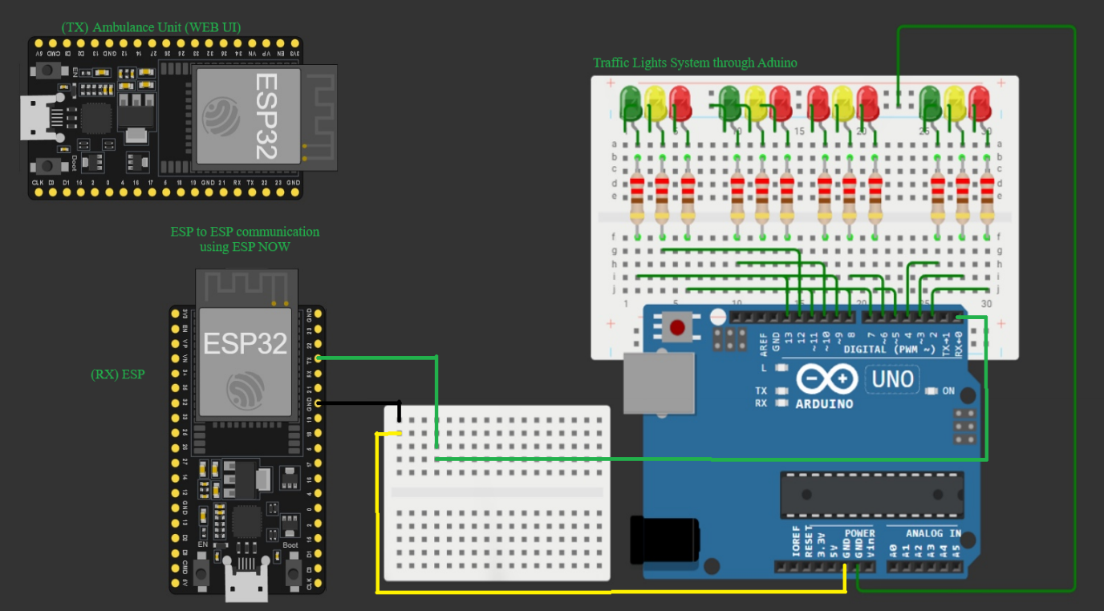
Figure 1: Hardware Implementation of Smart Ambulance Green Corridor System Using ESP32 and Arduino UNO
Connections Summary:

- ESP8266 TX → Arduino D2 (RX)
- ESP8266 RX → Arduino D3 (TX via voltage divider)
- ESP8266 GND → Arduino GND
- ESP32 communicates with ESP8266 over Wi-Fi network
- LEDs connected to Arduino digital pins D4–D11 for four roads.

Working :
The Smart Ambulance Green Corridor System works by allowing an ambulance to directly communicate with a traffic signal using wireless technology. Instead of depending on the internet, mobile network, or traffic police, the system uses fast device-to-device communication so that the ambulance can instantly request a green light on the required road. The entire process is automatic, reliable, and designed to reduce ambulance delay during emergencies
This figure shows the overall working flow of the Smart Ambulance Green Corridor System, where the ambulance selects a road, the ESP32 transmitter sends the command, the receiver processes it, and the traffic lights change to create a safe green corridor.

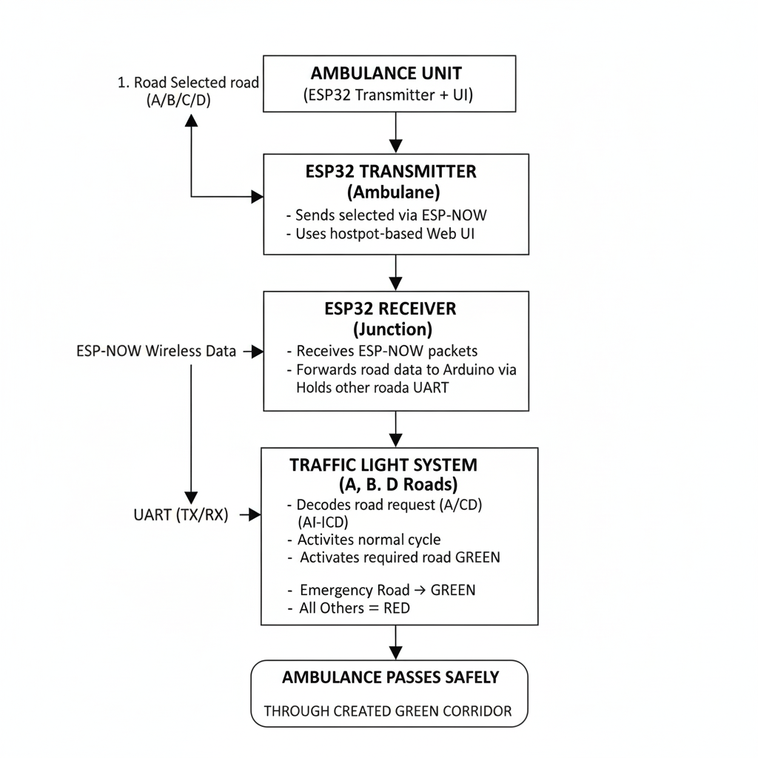
Figure 2: Flowchart Showing Communication and Traffic Signal Activation Process
The complete working is explained below in simple steps: Step-by-step Working Process

1. System Initialization
- When the system is powered on, two ESP32 modules start working:
  - One in the ambulance (Transmitter)
  - One at the traffic junction (Receiver)
- Both ESP32 boards activate ESP-NOW, a special wireless protocol used for fast communication without internet.
- The receiver ESP32 notes its MAC address, and the transmitter recognizes it as the authorized device.
- The Arduino connected to the receiver sets all the traffic lights to RED as a safe starting condition so no accident risk exists.
Why this step is needed:
The system must begin in a stable and safe condition before any emergency command is sent.
2. Ambulance Operator Connects to ESP32 Webpage
- The ESP32 in the ambulance creates its own Wi-Fi hotspot.
- The operator connects their phone to this hotspot.
- A webpage opens where the operator can simply choose the road (A, B, C, or D).
- There is also a button for NORMAL mode to restore normal traffic.
Why this step is needed:
The ambulance staff can easily select the correct road without using internet or a mobile network.
3. Road Selection by the Ambulance
- When the operator taps a button (for example Road B), the phone sends that selection to the ambulance ESP32.
- The ESP32 converts the selection into a small message such as "A", "B", "C", "D", or "NORMAL".
Why this step is needed:
Small messages ensure extremely fast wireless communication.
4. Sending Emergency Request Through ESP-NOW
- The ambulance ESP32 now sends the selected road message directly to the receiver ESP32 using ESP-NOW.
- ESP-NOW delivers the message within a few milliseconds.
- It does not require internet, routers, SIM cards, or towers.
- Communication happens directly from one ESP32 to another using their MAC addresses.
Why this step is needed:
It provides a very fast and 100% offline communication method ideal for emergencies.

5. Receiver ESP32 Processes the Emergency Command
- The ESP32 at the junction receives the message.
- It checks the sender MAC address to ensure the request came from the ambulance.
- It reads the message and displays it on the Serial Monitor for confirmation.
Why this step is needed:
Ensures that only authorized ambulances can trigger the system.
6. Forwarding the Message to Arduino
- The receiver ESP32 sends the same message to Arduino using UART (serial communication).
- Example:
  - If ESP32 receives "C", Arduino receives "C\n".
  - If ESP32 receives "NORMAL", Arduino gets "NORMAL\n".
Why this step is needed:
Arduino controls the actual traffic lights, so it must know which road needs the green signal.
7. Arduino Controls the Traffic Lights
(a) Emergency Mode
- If Arduino receives "A", "B", "C", or "D":
  - It first turns all signals RED for safety.
  - Then it turns only the selected road GREEN.
  - All other roads remain RED.
Example:
If "B" is received, only Road B becomes GREEN.
Why this step is needed:
It creates a safe and clear passage for the ambulance.
(b) Normal Mode
- When Arduino receives "NORMAL":
  - It cancels the emergency mode.
  - It starts the normal 4-way signal cycle:
    - A & C Green → Yellow → Red
    - B & D Green → Yellow → Red
Why this step is needed:
Traffic returns to normal once the ambulance has passed.
8. Continuous Monitoring
- The transmitter ESP32 can send commands repeatedly if required.
- The receiver ESP32 always listens for new packets.
- Arduino keeps checking for incoming commands.
Why this matters:
The system stays active and ready for the next emergency at all times.
9. Reset After Ambulance Passes
- Once the ambulance crosses the junction, the operator presses NORMAL.
- ESP32 transmitter sends "NORMAL" to the receiver.
- Arduino returns the traffic lights to the normal automatic sequence

Results:
The system was tested under multiple real-world conditions using a 4-way junction prototype (Roads A, B, C, D). Each test validates how effectively the IoT-based ambulance priority system clears the path and how the system behaves during faults like Wi-Fi loss or power reset.
The results show that the system successfully identifies ambulance requests, switches to the correct green corridor, and safely returns to normal mode without causing traffic conflicts.
This figure shows the graphical simulation of a four-way traffic junction used in the Smart Ambulance Green Corridor System. The interface displays the start road, destination road, and dynamic signal indicators (red and green lights) for each direction. It visually demonstrates how the system assigns a green corridor for the ambulance based on its selected route.

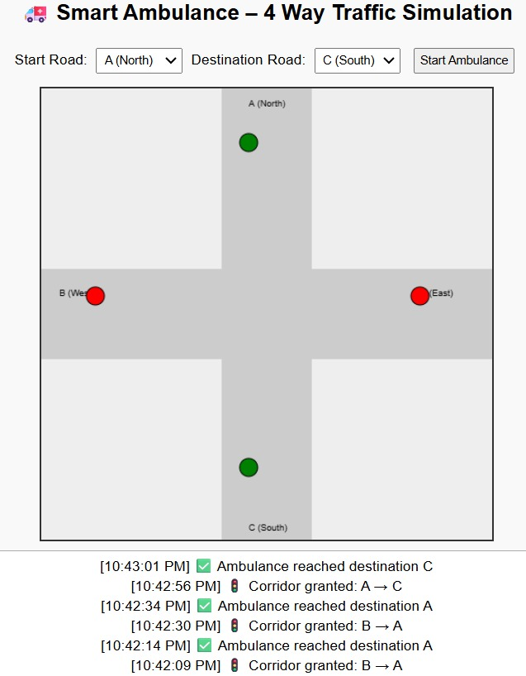
Figure 3: Simulation of 4-Way Traffic Signal Control for Smart Ambulance Green Corridor
Below is the explanation for each test case.

Case | Start Road | Destination | Action | Result
1 | A | C | A & C → Green | Ambulance passed
2 | B | D | B & D → Green | Smooth clearance
3 | A | B | A & B → Green | Route cleared
4 | C | A | C & A → Green | Verified
5 | D | B | D & B → Green | Worked properly
6 | Normal Mode | - | All signals in sequence | Verified
7 | Wi-Fi lost | - | Default cycle | Fail-safe active
8 | Power reset | - | Automatic reconnect | Verified
9 | Manual override | - | Controlled manually | Tested
10 | Multi-route request | - | Priority to first call | Safe handling

Advantages:
- Faster Emergency Response Time
The system clears the traffic signal before the ambulance reaches the junction. This removes signal delays and cuts several minutes from the response time — which directly increases patient survival chances during critical golden-hour cases.
- Removes Human Dependence
Traditional methods rely on drivers giving way or traffic police manually intervening. Your system automates preemption using the driver’s app, making it consistent and reliable irrespective of human behavior, traffic chaos, or road discipline.
- Low-Cost Implementation
Compared to GPS-based smart-city level infrastructure or expensive UWB anchors, this model uses Arduino + ESP modules. It is realistic enough to demonstrate actual workflow without requiring large government-grade investment.
- Works for Any Junction and Any Direction
Since the driver selects the road manually in the app, the system can handle any ambulance direction — A→C, B→D, etc. No need for location sensors that might fail indoors or due to weather.
- Improves Overall Traffic Flow During Emergencies
Instead of stopping all vehicles randomly, only the required roads transition to red/yellow in a controlled manner. This reduces confusion and minimizes the risk of accidents during emergency clearance.
- Scalable for Real-World Deployment
The same logic can be extended to:
  - Fire trucks
  - Police emergency vehicles
  - VIP movement
  - Multi-junction coordination
The architecture (ESP32 → Server/ESP8266 → Signal Controller) is scalable.
- Reduces Congestion at Intersections
Traffic lights follow normal cycles when there is no emergency, ensuring smooth flow. Emergency preemption is temporary and cleanly returns to normal mode after clearing the ambulance path.

Disadvantages
- Manual Road Selection Is Error-Prone
The system depends on the driver selecting the correct road in the app. If the driver chooses the wrong road or delays the trigger, the signal might clear the wrong direction — reducing system effectiveness.
- No Automatic Ambulance Detection
Since you removed GPS/UWB/IR systems, the signal controller cannot automatically verify the ambulance location. This makes the system purely manual and limits accuracy in real-world deployment.
- Wi-Fi Range & Connectivity Limitations
The ESP8266-based hotspot has limited range (~30–40 meters indoors). If the ambulance is too far or signal drops, the command won’t reach the controller. Real-world systems require LTE or dedicated RF channels.
- No Multi-Ambulance Priority Logic Yet
The current system cannot intelligently resolve conflicts if two ambulances request priority at the same junction simultaneously. In real deployments, ETA-based or route-based arbitration is required.
- Hardware-Level Reliability Concerns
Because the prototype uses jumper wires and breadboards, loose connections, brownouts, or voltage mismatch with ESP8266 can cause signal failures. A real-world system needs industrial-grade PCBs and power isolation.
- Security Risks
Anyone connected to the ESP8266 hotspot who knows the IP endpoints can trigger emergency mode. Without authentication, the system can be misused, leading to unwanted traffic manipulation.
- No Confirmation Feedback Loop from Arduino
The driver app assumes the road is cleared once the button is pressed, but cannot verify it. Without feedback from the signal controller, there’s no guarantee the clearance succeeded.

Applications:
The Smart Ambulance Traffic Management System has a wide range of practical applications in real-world urban environments, especially where emergency response time is critical. Its combination of automated traffic signal priority, wireless communication, and controlled intersection management makes it impactful across public health, transportation, and smart-city infrastructure.
1. Emergency Medical Services (EMS)
This system is primarily designed to help ambulances reach hospitals faster during emergencies. By giving real-time priority at traffic junctions, it reduces delays caused by red lights and dense traffic, helping patients in critical conditions get life-saving treatment sooner.
2. Smart City Traffic Management
Modern smart cities require intelligent systems to manage increasing vehicle density. This system can be integrated into municipal traffic control frameworks to enhance overall efficiency. With centralized monitoring, multiple intersections can automatically respond to emergency vehicles across the city.
3. Fire Brigade Vehicles
Fire trucks face the same delays as ambulances. This system can instantly clear paths for fire engines, allowing them to reach accident sites, building fires, or natural disaster zones quickly, preventing further damage and saving lives.
4. Police Emergency and VIP Transport
Police vehicles responding to distress calls, crime scenes, or high-priority security tasks can use the same priority mechanism to navigate congested areas. It is also applicable for VVIP convoy movements, ensuring controlled and safe intersection passage.
5. Accident and Disaster Response
In scenarios like road accidents, natural calamities, or chemical leaks, multiple emergency vehicles may need fast access. The system can coordinate prioritization of rescue vehicles across multiple junctions, improving large-scale disaster response speed.
6. Reducing Traffic Blockages During Emergencies
When an ambulance gets stuck at a junction, it causes panic among nearby vehicles, leading to disorganized movements and accidents. This system prevents such chaos by making the traffic light handle the situation smoothly and safely, reducing unnecessary blockages.
7. Integration with Hospitals
Hospitals can integrate this system into their emergency departments. When a patient is reported or an ambulance departs, the hospital can trigger priority signals along the predicted route toward the emergency ward, improving coordination.
8. Highway and Expressway Entry/Exit Management
Ambulances often struggle when entering or exiting highways during peak times. Smart signal preemption ensures that entry points and merging lanes are cleared, reducing the chance of collisions and easing access for emergency units.
9. Support for Rural and Semi-Urban Areas
Even areas without full smart-city infrastructure can deploy smaller, low-cost prototypes of this system using Arduino/ESP modules. This brings life-saving technology to towns that lack advanced traffic management systems.
10. Training and Simulation
The system can be used in engineering colleges, emergency management programs, and traffic police academies to simulate real-time emergency handling. Students can learn traffic control, wireless communication, IoT, and smart-city infrastructure through practical demonstrations.
11. Research and Development in ITS (Intelligent Transportation Systems)
Researchers can use this prototype as the foundation for more advanced work like:
- Vehicle-to-Infrastructure (V2X) communication
- AI-based traffic prediction
- Automated emergency routing
- Real-time digital twins for traffic networks

Future Scope:
The Smart Ambulance Traffic Management System has significant potential for advancement and real-world deployment. As cities move toward automation and AI-driven transportation, the system can evolve far beyond the current prototype. The following points highlight the long-term future scope and innovations that can be built on top of this project.
1. Full Smart-City Integration
The system can be expanded to integrate with centralized city traffic control centers. A cloud-connected platform can monitor all junctions simultaneously and automatically create a city-wide green corridor for ambulances, fire engines, and police vehicles. With real-time traffic maps and routing algorithms, the system could pre-clear every junction along the ambulance’s expected path.
2. AI-Based Automatic Ambulance Detection
Machine learning models and computer vision (CCTV + deep learning) can detect ambulances automatically using:
- Siren pattern recognition
- Vehicle shape detection
- Flashing light identification
This eliminates the need for manual driver input and removes human error from the system.
3. Integration of Vehicle-to-Infrastructure (V2X) Communication
Future automobiles will have V2X modules allowing direct communication with traffic lights. Emergency vehicles can automatically send authenticated priority requests to nearby signals. This enables instant preemption without requiring mobile apps or manual triggers.
4. GPS / UWB-Based Real-Time Tracking
Highly accurate systems like Ultra-Wideband (UWB) or improved GNSS modules can track ambulance positions with centimeter-level accuracy. Traffic lights will autonomously adjust based on the vehicle’s movement, speed, and predicted arrival time.
5. Multi-Ambulance Conflict Resolution
In real emergencies, more than one ambulance may approach the same junction from different roads. The future version of this system can include:
- ETA calculation
- Severity-based prioritization
- Automatic conflict arbitration
This ensures the safest and most efficient clearance path.
6. Cloud Dashboard for Hospitals & Traffic Police
A centralized dashboard can show:
- Live ambulance locations
- Traffic light status
- Route clearance progress
- Estimated arrival times
This improves coordination between hospitals, emergency operators, and police units.
7. IoT-Based Health Monitoring for Traffic Controllers
The system can evolve to include diagnostics and predictive maintenance features. Traffic signals often fail due to electrical faults; IoT sensors can alert authorities about low voltage, LED failure, or controller overheating, preventing disruptions.

Conclusion
The Smart Ambulance Traffic Management System successfully demonstrates how intelligent traffic control can significantly improve emergency response times in congested urban environments. By integrating a simple and reliable communication bridge between the ambulance driver’s app, the ESP modules, and the Arduino-based traffic junction controller, the system achieves seamless traffic signal preemption without relying on complex or expensive hardware. The project effectively simulates real-world traffic behavior, including normal signal cycles and controlled transitions into emergency priority modes, ensuring both safety and efficiency.
The design eliminates common problems associated with traditional traffic clearance, such as manual police intervention, human delay, or confusion at intersections. The system ensures that when an ambulance approaches a particular road, the corresponding traffic signals adjust automatically to create a direct green corridor, while all other directions switch to red. This controlled and predictable behavior minimizes accident risks and avoids chaotic vehicle movement. The system also ensures that after the emergency clearance is completed, junctions return smoothly to their normal operating cycle.
Although this prototype relies on manual road selection by the driver, it clearly establishes the foundation for more advanced smart-city implementations. The architecture can be scaled using GPS, computer vision, UWB, AI-based routing algorithms, and centralized traffic management systems. It also holds potential for handling multi-ambulance scenarios, integrating authentication systems to prevent unauthorized access, and implementing cloud-based dashboards for hospitals and traffic authorities. Overall, the project proves that even low-cost IoT and embedded systems can deliver impactful solutions that enhance public safety and support modern urban mobility challenges.
This work demonstrates strong academic relevance, practical usefulness, and future extendibility. It provides a viable direction for future researchers, engineering students, and smart-city planners to build more robust, automated, and intelligent traffic management infrastructures. With continued development, the system could become part of real-world emergency protocols that help save countless lives by ensuring faster and safer medical transportation.

References
- Arduino UNO R3 Documentation, Arduino Foundation – Technical specifications, microcontroller behavior, and interfacing guidelines.
- ESP8266/ESP32 Technical Reference Manuals, Espressif Systems – Details on Wi-Fi communication, AT commands, GPIO functions, and embedded networking.
- Intelligent Transportation Systems (ITS) Standards, IEEE – Guidelines for V2X communication, emergency vehicle preemption, and smart traffic systems.
- Traffic Signal Control Principles, National Highway Traffic Safety Administration (NHTSA) – Standard timing cycles, yellow/red transitions, and emergency routing protocols.
- Smart City Mission – Government of India – Framework for IoT-based traffic solutions, real-time monitoring, and urban transportation improvements.
- Research Papers on Emergency Vehicle Preemption – Various IEEE and Springer publications discussing GPS-based priority systems, IoT-driven traffic control, and machine learning for signal optimization.
- IoT-Based Traffic Monitoring Studies – Academic works detailing wireless communication between controllers, sensor integration, and cloud-driven automation.
- Web-Based User Interface Design Guidelines, MDN Web Docs – For building mobile-friendly HTTP interfaces used in the ambulance driver app.
- Embedded Systems Design Tutorials, NPTEL – Referenced for safe hardware interfacing, voltage level requirements, and serial communication.

